### 

### Semester One Examination, 2022

### Question/Answer booklet

# MATHEMATICS SPECIALIST

**UNIT 3**

## Section One:

## Calculator-free

|  |
| --- |
|  |

Your Name

Your Teacher’s Name

## Time allowed for this section

Reading time before commencing work: five minutes

Working time: fifty minutes

## Materials required/recommended for this section

***To be provided by the supervisor***

This Question/Answer booklet

Formula sheet

***To be provided by the candidate***

Standard items: pens (blue/black preferred), pencils (including coloured), sharpener, correction fluid/tape, eraser, ruler, highlighters

Special items: nil

## Important note to candidates

No other items may be taken into the examination room. It is **your** responsibility to ensure that you do not have any unauthorised material. If you have any unauthorised material with you, hand it to the supervisor **before** reading any further.

|  |  |  |  |  |  |
| --- | --- | --- | --- | --- | --- |
| Question | Mark | Max | Question | Mark | Max |
| 1 |  |  | 5 |  |  |
| 2 |  |  | 6 |  |  |
| 3 |  |  | 7 |  |  |
| 4 |  |  | 8 |  |  |

**Structure of this paper**

|  |  |  |  |  |  |
| --- | --- | --- | --- | --- | --- |
| Section | Number of questions available | Number of questions to be answered | Working time (minutes) | Marks available | Percentage of examination |
| Section One:  Calculator-free | 8 | 8 | 50 | 52 | 34 |
| Section Two:  Calculator-assumed | 14 | 14 | 100 | 97 | 65 |
|  |  |  |  | **Total** | 100 |

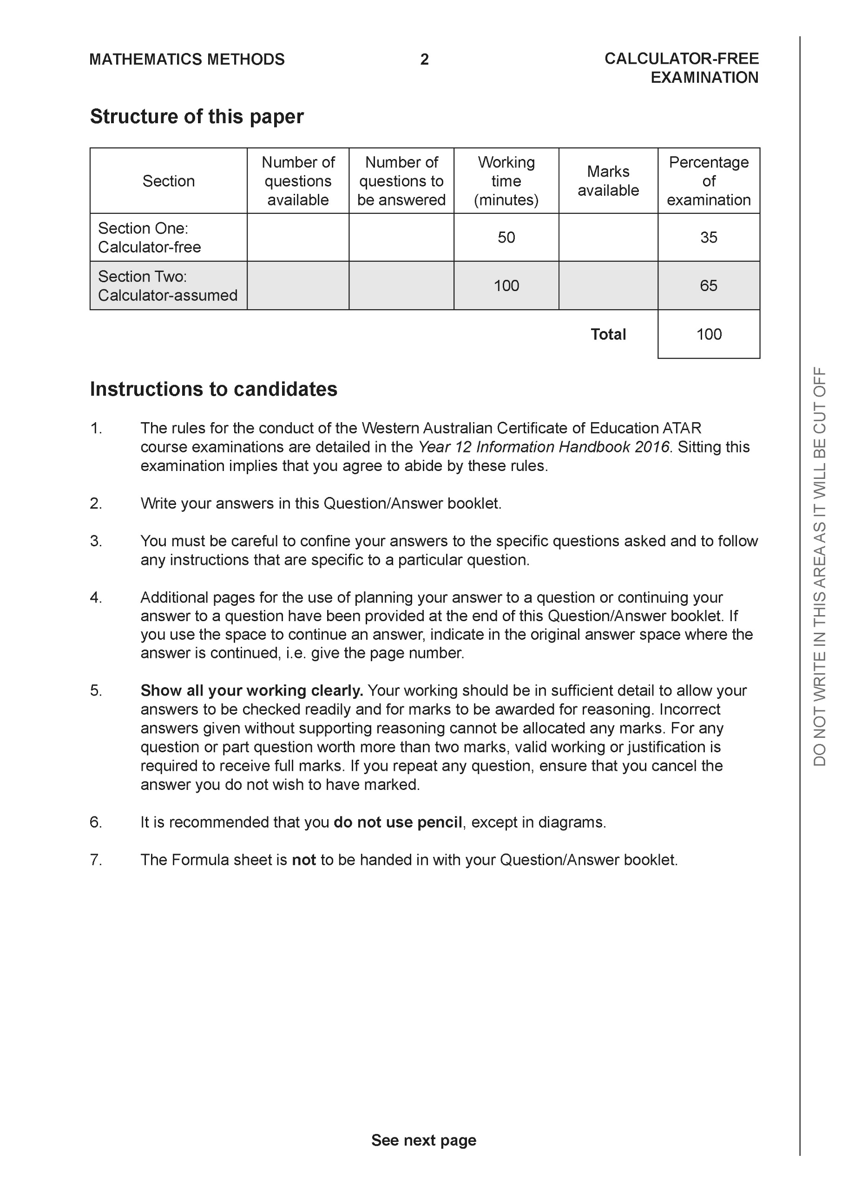

**Section One: Calculator-free (52 Marks)**

This section has **eight (8)** questions. Answer **all** questions. Write your answers in the spaces provided.

Spare pages are included at the end of this booklet. They can be used for planning your responses and/or as additional space if required to continue an answer.

● Planning: If you use the spare pages for planning, indicate this clearly at the top of the page.

● Continuing an answer: If you need to use the space to continue an answer, indicate in the original answer space where the answer is continued, i.e. give the page number. Fill in the number of the question that you are continuing to answer at the top of the page.

Working time: 50 minutes.

**Question 1 (4 marks)**

Consider the complex number  as plotted on the complex plane below.

1. Determine the exact value of  and plot on the axes above. (2 marks)

|  |
| --- |
| **Solution** |
|  |
| **Specific behaviours** |
| P uses rotation of 90 degrees  P states argument |

1. Determine the exact value of. (2 marks)

|  |
| --- |
| **Solution** |
|  |
| **Specific behaviours** |
| P uses triangle rule  P states exact value that must be simplfied |

**Question 2 (8 marks)**

Consider the functions  with domains shown in the graphs below.

|  |  |  |  |  |  |
| --- | --- | --- | --- | --- | --- |
| 1. Sketch the inverse functions above.   If they exist. (2 marks)   |  | | --- | | **Solution** | |  | | **Specific behaviours** | | P states that f does not exist  P sketches inverse of g with correct endpoints | |  |

1. Which of the following exist over natural domains,  ,  ? Explain.

State the natural domain and corresponding ranges for those that exist. (3 marks)

|  |
| --- |
| **Solution** |
|  |
| **Specific behaviours** |
| P states domain and ranges of both functions in argument  P shows that fog exists with condition  P shows that gof does not exist with condition |

1. The rule for  is . State the inverse rule  and its domain. (3 marks)

|  |
| --- |
| **Solution** |
|  |
| **Specific behaviours** |
| P swaps x & y  P solves for inverse  P states domain |

**Question 3 (5 marks)**

Consider the function .

Plot on the axes below labelling intercepts and asymptotes.

|  |
| --- |
| **Solution** |
|  |
| **Specific behaviours** |
| P shows and labels vertical asymptote  P shows and labels oblique asymptote (accept y=x)  P shows and labels x intercepts  P shows and labels y intercept  P shape is correct |

**Question 4 (8 marks)**

Consider the polynomial  for the complex variable .

1. Given that , determine a quadratic factor of . (3 marks)

|  |
| --- |
| **Solution** |
|  |
| **Specific behaviours** |
| P uses conjugate  P correct coefficient of x  P correct quadratic factor |

1. If , determine all solutions to . (2 marks)

|  |
| --- |
| **Solution** |
|  |
| **Specific behaviours** |
| P states 2 solns  P states all 4 roots |

1.  can be expressed as  where  are real integers. Determine the values of . (3 marks)

|  |
| --- |
| **Solution** |
|  |
| **Specific behaviours** |
| P uses conjugate of -2-i  P uses a=3  P states both quadratic factors |

**Question 5 (7 marks)**

Consider the function .

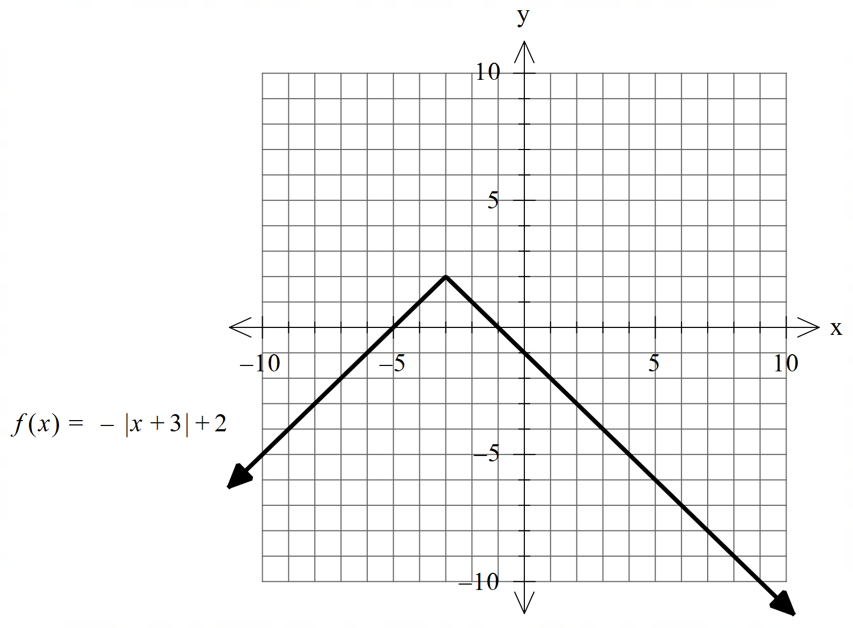

1. Sketch  on the axes below, labeling important features. (4 marks

|  |
| --- |
| **Solution** |
|  |
| **Specific behaviours** |
| P shows and labels both asymptotes  P y intercept is -1, (no need to label)  P x axis appears to be an asymptote  P correct shape with turning point (-3,0.5) |

1. Hence determine the natural domain and range of  (3 marks)

|  |
| --- |
| **Solution** |
| i.e Range of g is all Real numbers **excluding**  i.e |
| **Specific behaviours** |
| P shows use of factor -1/3 and graph in (a) or other stated reasoning  P states domain  P states range |

**Question 6 (6 marks)**

Consider the linear equations 

1. Solve for . (3 marks)

|  |
| --- |
| **Solution** |
|  |
| **Specific behaviours** |
| P eliminates one variable from two equations  P eliminates two variables from one equation  P solves for all unknowns |

1. Consider the following system where  are constants. (3 marks)

Solve for all possible values of for the following scenarios:

1. Unique solution
2. Infinite solutions
3. No solutions.

|  |
| --- |
| **Solution** |
|  |
| **Specific behaviours** |
| P obtains an equation with two variable eliminated and in terms of p&q  P states requirement for uniqueness  P states requirements for infinite and no solns |

**Question 7 (10 marks)**

Consider the function  for  which is plotted below.

1. Sketch the inverse function  on the axes above. (2 marks)

|  |
| --- |
| 1. **Solution** |
|  |
| **Specific behaviours** |
| P appears reflected in line y=x  P correct endpoint |

b)Determine the rule for  and state its domain. (4 marks)

|  |
| --- |
| **Solution** |
|  |
| **Specific behaviours** |
| P states domain  P swaps x & y of solves for x  P states inverse rule with two possibilities  P discards positive to give only one rule |

Q7 continued.

c) Determine  (1 mark)

|  |
| --- |
| **Solution** |
|  |
| **Specific behaviours** |
| P states x |

d) Determine the exact coordinates, if any, where  (3 marks)

|  |
| --- |
| **Solution** |
|  |
| **Specific behaviours** |
| P equates to x and solves for two values  P discards the positive value  P states **simplified** exact coordinates for point |

**Question 8 (4 marks)**

Consider two parallel planes . Plane  is given by  and plane  contains the point .

Show that the distance between the two planes is given by 

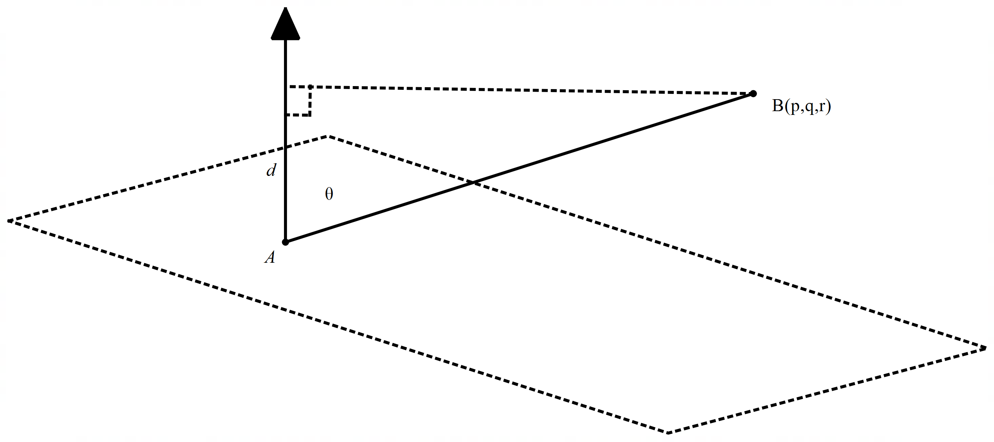

|  |
| --- |
| **Solution** |
|  |
| **Specific behaviours** |
| P finds a point on plane  P uses dot product with **normal and separation** vector  P uses unit normal vector  P shows derivation of final expression  Note: max of 1 mark if separation vector or line equation not used  Note: (p,q,r) is not on first plane and therefore cannot be subs into vector eqn |

Additional working space

Question number: